TONGWEI AQUANEWS
Issue 1, June 6, 2008

Sichuan Aquacultural Engineering and Technology Research Center

Editor’s Message
Updated Aquaculture and Fisheries Production Data in China
China's Annual Feed Production Exceeding 100 Million Tons for 3 Consecutive Years
China’s Aquaculture Hit by Snowstorm
China’s Aquaculture Hit by Earthquake
Shrimp Feed Price unlikely to Rise Further in China
Shanghai Fisheries University Renamed as Shanghai Ocean University
China's Fish Farms Are Cleaner - for Now
Tongwei – World Leading Aquafeed Producer
Editor’s Message
China is the world largest aquaculture production country. However, the information on aquaculture in China has not been well disseminated to the other parts of the world, due mainly to the language barrier. The Tongwei Aquanews has been launched by Sichuan Aquacultural Engineering and Technology Research Center, established jointly by Tongwei Co. Ltd. and Sichuan provincial government and located in Chengdu of Sichuan province. The Tongwei Aquanews is aiming to provide the latest information on Chinese aquaculture and promote information exchange among aquaculturists worldwide.

Updated Aquaculture and Fisheries Production Data in China
The updated data of aquaculture was released by Chinese government recently.
In 2007, the aquaculture area in China reached 5.63 million hectares, with an increase of 1.95% compared to that in 2006. The marine aquaculture area was 1.33 million hectares and increased by 4.68%, while the freshwater aquaculture area was 4.30 million hectares and increased by 1.13%. The aquaculture areas were 1.77 million hectares for ponds, 1.06 million hectares for lakes and 1.26 million hectares for reservoirs, increasing by 2.48%, 2.19% and -1.78%, respectively.
In 2007, the total production of aquaculture/fisheries products in China was 47.475 million tons, increasing by 3.58% over that in 2006. Among the total production, the production from marine aquaculture, freshwater aquaculture, marine capture and freshwater capture was 13.073, 19.71, 12.435 and 2.256 million tons, increasing by 3.42%, 6.33%, -0.15% and 2.39%, respectively, compared to that in 2006. The ratio of aquaculture to capture is 69:31, increasing by 1% over that in 2006, while the ratio of marine to freshwater production is 54:46, decreasing by 1% over that in 2006.
Source: China Fishery News, April 16, 2008.

China's Annual Feed Production Exceeding 100 Million Tons for 3 Consecutive Years
China's annual feed production has exceeded 100 million tons for 2 consecutive years starting from 2005, accounting for 20% of the world total, and has been the second largest feed producer for 17 consecutive years, only next to USA.
In 2007, the total production of industry feed including compound feed, concentrated feed and premix reached 123 million tons, increasing by 11.5% over that in 2006. The production of compound feed, concentrated feed and premix was 93.19, 24.91 and 5.21 million tons, with increases of 14.8%, 1.4% and 7.2% over those in 2006, respectively,
Compared to 2006, the proportion of compound feed increased by 3%, and that of concentrated feed decreased by 3%, while premix proportion remained unchanged.
In 2007, pig feed production decreased by 0.4%, but the production of layer and broiler poultry feeds, aquafeed and ruminant feeds increased over those in 2006.
In 2007, there was a total of 15,376 feed mills in China, with 125 less than that in 2006, decreasing by 0.8%.
During January- April 2008, the total feed production reached 39.20 million tons, increasing by 13.6% over the same period of 2007. Among which, the production of compound feed, concentrated feed and premix was 30.90, 6.80 and 1.40 million tons, increasing by 14.0％, 12.4% and 7.5%, respectively. The production of pig feed, layer and broiler poultry feed, ruminant feed and aquafeed was about 13.40, 7.30, 12.60, 1.12 and 3.96 million tons, increasing by 12.4%, 7.5%, 17.8%, 7%, and 13.0%, respectively. But feeds for other animals were around 0.82 million tons, which was slightly less than that in the same period of 2007.
It is predicted that the total feed production in 2008 will exceed 130 million tons, with more than 10% increment.
Source: The Information Centre of China Feed Industry Association and China Feed Magazine, May 2008.

China’s Aquaculture Hit by Snowstorm

Starting from 10 January 2008, the east region of Northwest China and most parts of Southern China were hit by snow storm for quite long period of time. It has caused serious damage to aquaculture industry in 19 provinces in the middle and lower reaches of the Yangtze River, including Guangdong and Guangxi provinces. Nearly ten thousand hectares of farming areas including recirculation culture facilities were affected by the snowstorm, causing the loss of 870,000 tons of aquatic products with value of nearly 100 million US dollars. About 570,000 m2 of houses for production use collapsed, and about 8.36 million m2 of greenhouses and hatcheries as well as 5.92 million m2 of cages were damaged. This caused the mortality of about 3.40 million pairs of broodstock, 420,000 tons of fingerlings and 450,000 tons of adult fish.
The areas mostly hit by the snowstorm are the main inland aquaculture areas as well as the major areas of fish hatching and fingerling supply, thus seriously affecting the aquaculture in these areas as well as in whole country. The mass mortality of broodstock and fingerlings will cause the supplies of fries and fingerlings and the table fish in May-August as well as the export of fish such as tilapias and channel catfish.
Currently, the major problems in the snowstorm affected areas include insufficient capital and labors for restoring the production, serious damages of seed production system, a shortage of fingerling supply, and the potential risk of the disease outbreak of aquatic animals. There are urgent needs of technical and financial support for farmers to restore the production in order to reduce the losses caused by the snowstorm.
Source: Ministry of Agriculture, February15, 2008.

China’s Aquaculture Hit by Earthquake
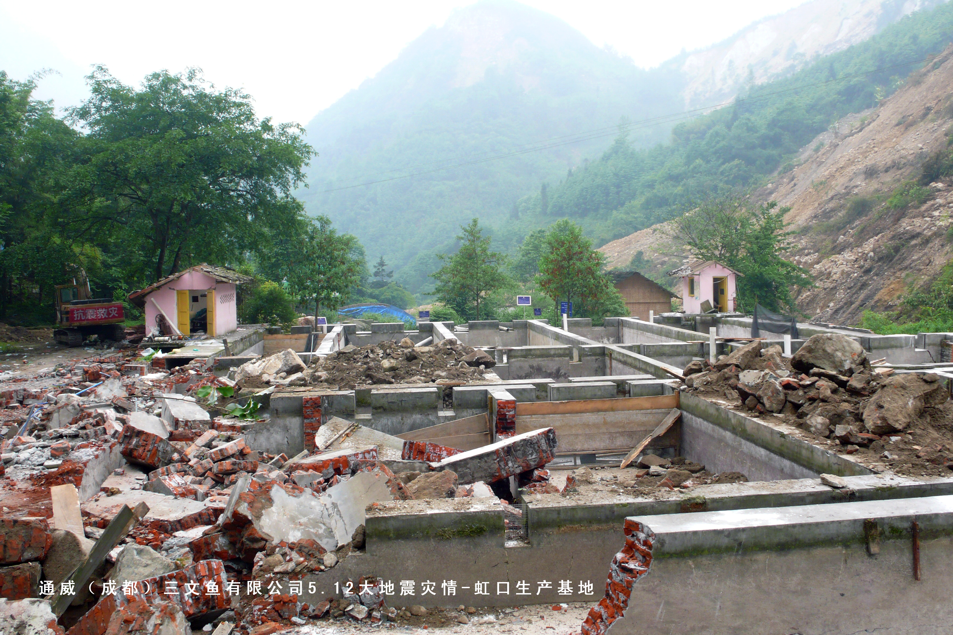
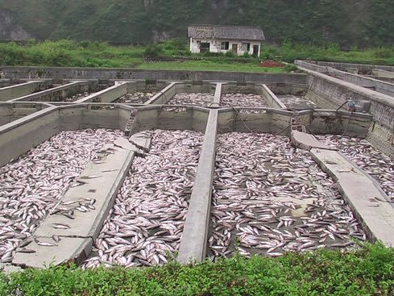

A strong earthquake of Richter scale of 8.0 occurred at 14:28 pm on 12 May 2008 in Wenchuan county of Sichuan Province, China. The aquaculture in Sichuan province, one of the major inland aquaculture provinces, and nearby provinces including Chongqing, Shanxi, Gansu and Yunnan has been hit seriously by the earthquake.
As of 23 May 2008, the affected aquaculture area in Sichuan province was 22,923 hectares, causing the loss of 22,461 tons of adult fish and 2,356 tons of juvenile fish. About 9,424 hectares of ponds, 16 hectares of cages and 183,756 m2 of farm houses were damaged. The total aquaculture economic loss in Sichuan province is estimated to be US$ 122 millions, accounting for 90.52% of the total aquaculture economic losses in the earthquake-hit areas in the country. The total aquaculture economic losses in Chongqing, Shanxi, Gansu and Yunnan were 5.0, 5.4, 1.0 and 1.4 millions US dollars, respectively.
Source: Fishery Bureau of Ministry of Agriculture, May 23, 2008.

Shrimp Feed Price unlikely to Rise Further in China
Since early 2006, shrimp feed price has been raised by 1,000 Yuan RMB (US$143) per ton to about 7,400 Yuan RMB (US$1.060) per ton after several rounds of price increases. At early April 2008, it was said that shrimp feed price would be increased again after the price was raised on 1 March 2008. However, an interviewee of the aquafeed industry said that it is very difficult for shrimp feed price to be raised again this year because the prices of major feed ingredients are relatively stable currently while the situation of shrimp farming is good.
Starting from 1 March 2008, shrimp feed price was increased by 300 Yuan RMB (US$43) per ton. In fact, the actual feed cost has increased by 500 Yuan RMB (US$71) per ton since 2007 due to large increase of feed ingredients, and the price might have been increased by 500 Yuan RMB (US$71) per ton by many feed mills. However, considering the downturn of shrimp faring last year and the limited bearing capacity of shrimp farmers, the shrimp feed price was only raised for 300 Yuan RMB (US$43) per ton.. The difference between the cost and price is bear by feed mills. The industry can not be developed healthily, if there is no profit at any of the aquaculture production chain.
Source: China Fishery News, April 29, 2008.

Shanghai Fisheries University Renamed as Shanghai Ocean University
Approved by Ministry of Education, Shanghai Fisheries University has been renamed as Shanghai Ocean University. In August 2008, the university will be relocated to Lingang, a small coastal new town, which is about 70 km from downtown of Shanghai. The new campus covers about 110 hectare of land area.
Established in 1912 with the name of Jiangsu Provincial Fisheries School, which was then changed to the name of Shanghai Fisheries College in 1952, becoming the first higher educational institution in fisheries and aquaculture in China. In 1985, it was renamed as Shanghai Fisheries University.
The university has been developed from a single-disciplinary to multi-disciplinary university, and from a teaching-oriented to teaching-research university, and the number of enrolled students increased from a few thousands to about 14,000. The university has made significant contributions in environmental protection, biodiversity protection, genetic breeding, food processing, marine resources development and utilization, aquaculture, agricultural economy and management and so on.
Source: China Fishery News, May 7, 2008.

China's Fish Farms Are Cleaner - for Now
The Chinese Ministry of Agriculture said a recent nationwide crackdown on the use of illegal veterinary drugs had already significantly improved the quality and safety of the country's seafood production.
Regulators said that over the past year more than 30,000 inspectors had fanned out across the country, working to close shoddy seafood operations and enforce regulations against the use of banned antibiotics, like chloramphenicol and malachite green, which is believed to cause cancer. But officials from the Ministry's Fisheries Bureau also said that pollution and water quality problems had become the biggest challenges facing China's fish farming or aquaculture industry, something they have rarely acknowledged in public. "Water quality is the top issue for Chinese aquaculture," Ding Xiaoming, the director of aquaculture in the ministry's fisheries bureau, said Tuesday. "Without good water quality, Chinese aquaculture cannot develop."
During a 30-minute interview at the Ministry of Agriculture in Beijing, Ding blamed China's rapid urbanization and industrialization for spoiling the environment and polluting waterways that are used by factory-style fish farms, a situation that experts say has forced some farmers to turn to illegal drugs. He said the government was rolling out an array of new programs and regulations to educate farmers and combat the quality problems.
The government's sweeping effort is aimed at restoring confidence in Chinese seafood exports after a year of food and product safety scandals involving everything from tainted seafood to toxic toys and toothpaste.
The stakes are huge because China is now the leading producer and exporter of seafood in the world and an important supplier to the United States and Japan. And with the seas increasingly depleted by overfishing, much of the world is turning to China's massive land-based fish farms to meet growing consumer demand for everything from shrimp and catfish to tilapia and eel. But after years of spectacular growth, this country's booming seafood industry is being threatened by water shortages, contaminated water supplies and illegal veterinary drug use.
In recent years, Japan and the European Union have imposed temporary bans on seafood imports from China because of excessive residues of illegal drugs. And last June, the U.S. Food and Drug Administration moved to block the import of several types of Chinese seafood products because of similar food safety concerns. Experts here say Chinese fish farmers often turn to illegal veterinary drugs because they can help keep fish alive in overcrowded fish ponds that are sometimes contaminated by sewage, agricultural runoff and industrial chemicals. Some of the banned veterinary drugs are believed to be highly effective in helping stressed fish cope with disease. But fish that are fed such drugs could be poisonous for consumers, regulators say.
Last year, China had by far the largest number of seafood imports rejected by the United States, according to records kept by the Food and Drug Administration. The vast majority of those rejected shipments were linked to illegal drug residues.
The Chinese government has responded aggressively in recent months by blacklisting seafood processors or revoking the licenses of companies that export seafood tainted with illegal drugs or other banned substances. But China has also lashed out at the United States and other countries that have blocked its food exports, insisting that the vast majority are safe and meet quality standards and that media coverage has often been sensational and distorted.
Beijing has pointedly criticized an article in The New York Times in December with the headline, "In China, Farming Fish in Toxic Waters." (The article appeared under a different headline in the International Herald Tribune.) It detailed some of the challenges facing China's seafood industry, noting that many producers had often used illegal veterinary drugs to cope with fishing or farming in polluted waters.
"It is a question of common sense. Do you believe that fish can live in toxic water?" Agriculture Vice Minister Gao Hongbin said at a news conference last week, responding to a question from a Reuters reporter. "Personally, I believe that this report is sensational and misleading." The state-controlled news media here was also critical of the article, quoting farmers and aquaculture officials as saying the report was "totally groundless." However, in the interview Tuesday, Ding, a high-ranking official at the fisheries bureau, said the article was accurate. But he called the headline sensational and erroneous. "I think your article was correct," he said Tuesday, but "it's not scientific to say the water is toxic." The interview was cut short, however, after Ding began acknowledging some of the industry's problems and seemed to contradict other agricultural officials, who criticized the article. Another fisheries bureau official attending the interview cut several questions off, suddenly declaring, "Thank you for coming." But before the session ended, Ding explained that regulators were having difficulty stopping polluters from damaging waterways used by fish farmers because much of the pollution occurs gradually.
While regulators acknowledge that small-scale farmers are difficult to patrol and crooked seafood processors give the industry a bad name, others insist that the food safety worries are vastly exaggerated and partly the result of protectionist efforts by interest groups in the United States and Japan that are trying to stop China from gaining market share. The seemingly contradictory statements may reflect divisions within the Chinese government over how to deal with a problem that could seriously harm one of the country's most valuable agricultural exports.
Despite food safety worries, China said its seafood exports grew to a record $8.7 billion in the year through November, although the rate of growth slowed to about 4 percent from 19 percent a year earlier.
Source: International Herald Tribune, January 17, 2008.

Tongwei – World Leading Aquafeed Producer
Tongwei Group Co. Ltd., a private company founded by the president Mr. Liu Hanyuan in 1992, has grown up from a manual workshop to the world-largest aquafeed producer and one of the world-leading livestock and poultry feed producers. In the meanwhile, Tongwei group has been engaged in diversified businesses including pet foods, chemical industry, IT, real estate, PV and so on, all of which have been being developed stably and rapidly. In 2006, Tongwei Group was ranked as top 100 private enterprises in China. Mr. Liu Hanyuan has been elected as a member of the Standing Committee of the National Committee of the Chinese People's Political Consultative Conference (CPPCC) and a member of the Standing Committee of the Central Committee of China Democratic National Construction Association.
Tongwei Co. Ltd., controlled by Tongwei Group Co. Ltd., is a listed company in agricultural science and technology sector of the Shanghai Stock Market (Stock Code:600438), mainly dealing with feed production, as well as aquaculture, aquaculture R&D, animal health and food processing. The company is always sticking to the corporate tenet of Striving for Excellence, Contributing to Society, pursuing the management concept of Honesty, Trust, Fairness and Excellence, taking Improving Quality of Life, Creating World-class Brand of Aquatic Products as its responsibility.
Currently, Tongwei Co. Ltd. owns more than 70 branches and subsidiary companies in China as well as overseas, including those in Beijing, Tianjin, Guangdong, Sichuan, Chongqing and Vietnam. The company’s annual capacity of feed production is more than 4.4 million tons. Relying on its R & D strength, the company has established eight R&D centers, such as the State-Level Enterprise Technology Center, Doctoral Students’ Working Station in Animal Nutrition of Sichuan Agricultural University, Postgraduate Training Base of Shanghai Fisheries University, jointly research laboratories with College of Aquaculture & Fisheries of Can Tho University and University of Agriculture and Forestry in Vietnam. The annual R&D fund in Tongwei Co. Ltd. is more than 2 million US dollars, and more than 100 research results and over two hundred research papers are produced by its more than 300 technical staff who specialize in animal nutrition, feed, breeding and fish gene engineering. Furthermore, the company has established Tongwei Aquatic Science & Technology Park with excellent facilities, which is the largest of its kind in Asia.
As the National Key Leading Enterprise of Agricultural Industrialization recognized jointly by nine Chinese ministries and commissions of the State Council such as Ministry of Finance and Ministry of Agriculture, “Tongwei” brand is the only symbolic brand in Chinese feed sector, and Tongwei Co. Ltd. is among a few Chinese companies simultaneously holding the three national highest honorable titles, namely “China’s Famous Trademark”, “Chinese Famous Brand” and “products exempt from quality surveillance inspection”. “Tongwei” brand, with a value of about 600 million US dollars, has been listed as Top 500 China’s Most Valuable Brand for 4 consecutive years.
Source: www.tongwei.com.cn

